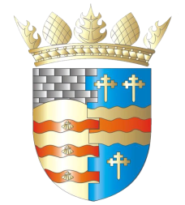

BLAIRGOWRIE AND RATTRAY COMMUNITY COUNCIL

Ordinary Meeting
Thursday, 8th December 2022, at 7pm
at the BaRI Building, 55 High Street, Blairgowrie, and online via Zoom

1. Welcome and Introductions
2. Apologies
3. Adoption of draft minutes of EGM & November Ordinary meeting
4. Matters raised by members of the public
5. Matters arising/reports back
a) Resilience/Flooding PR/SM
b) Climate Action DC/GP
c) Twinning GP
d) Maintenance in Blairgowrie and Rattray CS/SM
e) Football Pitch CS/SM
f) Christmas Wish Tree/Letters to Santa SS
g) Nativity
6. New Projects
7. Traffic Matters
8. Planning Matters
9. Police & Fire Reports
10. Chair’s Report
11. Treasurer’s Report
12. Secretary’s Correspondence
13. Councillors’ Reports
14. AOCB

Please note: With the permission of all attendees, the minute taker will record this meeting solely for the purpose of writing up the minutes, will not share the recording, and will delete the recording as soon as the minutes have been written. The Chair will ask for permission at the start of the meeting.

Awaiting new information: CCTV, Representation of Young People, Citizen of the Year, Community Action Plan, Fireworks, Noticeboards, PA System for the Town, 5th November Event

Next meeting: Ordinary Meeting, Thursday, 12th January 2022, 7.00pm

